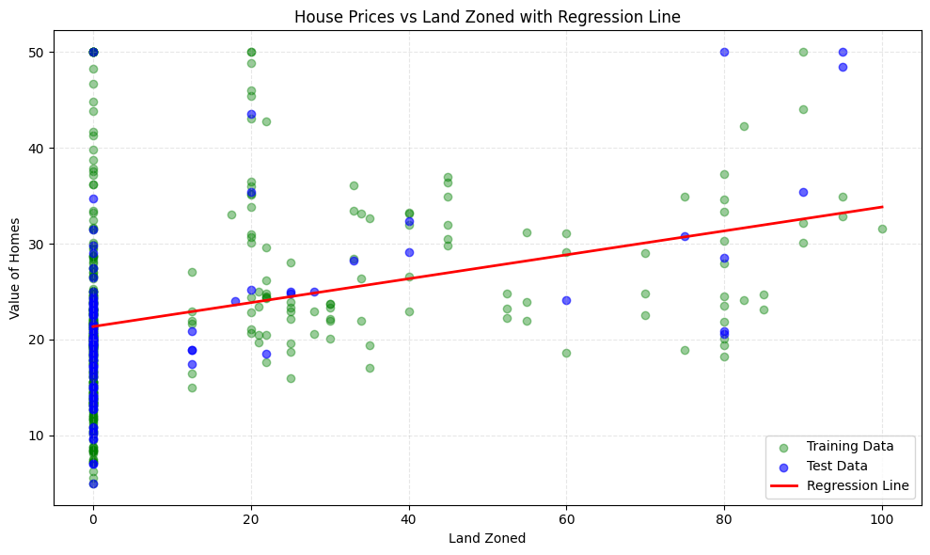  
The predicted values are almost at the mean of the actual values which suggest that the accuracy for our model could be improved a little bit more.

Simple

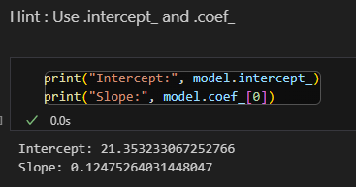

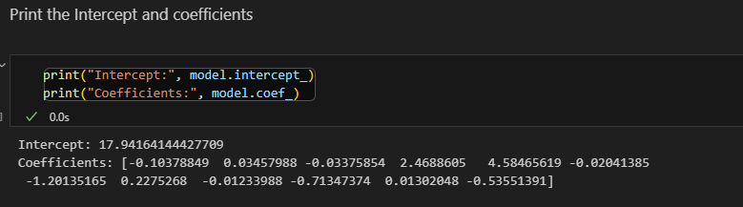

As shown above in the multiple regression we have more than one coefficient because each one of the coefficients here is for each column in the X variable

For the simple regressor its

Y = mx+B

But for the multiple regressor its

Y = m1x1 + m2x2 + m3x3… + b